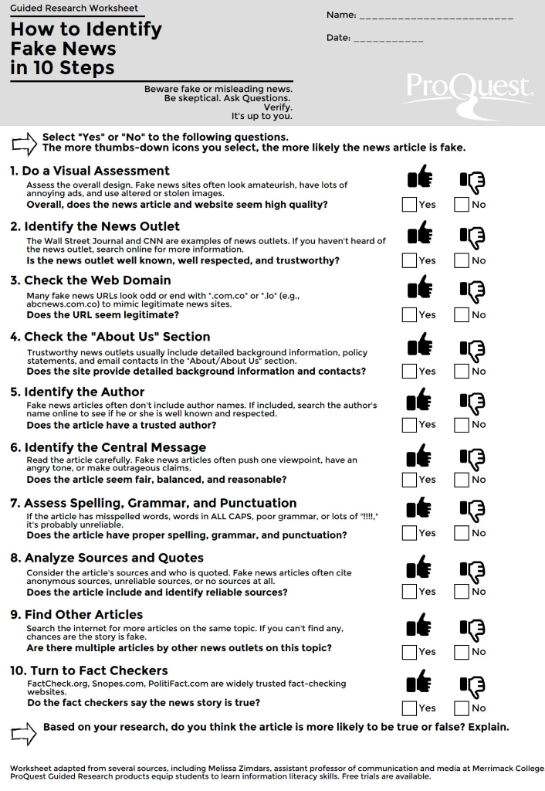
Tools to Use:
Step 1 – Use a Fact Checking Link -
bit.ly/fact-search
Step 2 – Checking the Source
- The easiest way to find the source is usually to follow links that will lead you to the original story.
- Use a search engine. See if you can find any information about where the story originally came from and do a search that includes that.
Step 3 – Verifying the Source -
- Do they really exist?
“About Us” pages and profiles are easy to fake, so use a search engine or Wikipedia to find out if other people say they really exist. Pay the most attention to things that are hard to fake.
- Are they who they say they are?
It’s easy to pretend to be someone else online, so once you know the source really exists, you need to find out if what you’re looking at really came from them.
- Are they trustworthy?
For sources of general information, like newspapers, find out if they have a process for making sure they’re giving you good information, and a good track record of doing it.
Step 4 - Check Other Sources
News search - bit.ly/news-search
Science search - bit.ly/science-search

Check these sites – Fake or Not?
https://www.dhmo.org/ Fake or Not? _________
Why? _______________________________________________________________________________________________________________________________________________________________________________________________________________________________________________________________

https://www.eatright.org/ Fake or Not? _________
Why? _______________________________________________________________________________________________________________________________________________________________________________________________________________________________________________________________
https://cutt.ly/gk2GE0C Fake or Not? _________
Why? _______________________________________________________________________________________________________________________________________________________________________________________________________________________________________________________________

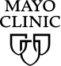
Healthy Lifestyle

Nutrition and healthy eating
When it comes to nutrition claims, deciphering fact from fiction can be confusing. Use these guidelines to make informed decisions about the food you eat.
By Jason S. Ewoldt
In a technology-driven world, it's more common than ever for people to search for health information online. However, social media and 24-hour news overload us with data, making it challenging to discern accuracy from false claims.
Deciphering fact from fiction can be especially daunting when it comes to nutrition. It seems like every week there's a new food-related headline, often with contradictory claims. One week coffee is a "cure-all" that boosts metabolism and immunity. The next week you might see an article linking coffee consumption to cancer. So how do you know what to believe?
The key to being a savvy investigator is to approach nutrition claims with skepticism and an inquisitive attitude. Credible nutrition information is based in scientific evidence. Here are some questions to ask when evaluating nutrition and diet information.
- Is the "evidence" simply testimonials or personal opinions?
Anecdotes and testimonials are not evidence. Just because people claim that something worked for them doesn't mean that a diet, food or strategy is supported by science.
- Does the claim sound too good to be true?
"Lose 20 pounds in 2 weeks!" A claim that promises a quick or extreme outcome should always signal a red flag. The claim probably isn't sustainable, realistic or even valid.
- Is the information sensationalized, with no references to expert opinion or research studies?
"Eating chocolate will keep you thin and healthy." Sensational headlines are usually written to simply grab a reader's interest but are not backed by research studies.
- Do the conclusions to what are considered complex issues seem too simple and easy?
"Taking probiotics can prevent colds and flu." In general, a complex issue such as the flu virus is not easily solved by one simple trick.
- Is the website, individual or company trying to sell something?
"Fuel your body with essential vitamins, minerals and superfoods once a day with our shakes!" "Look and feel great for $9 a day!" Usually when a product is being sold, the motivation is profit and not your actual well-being. Ask yourself: "Has the article been written without any biases?"
Asking these questions can help you hone your critical thinking skills and maintain a healthy degree of skepticism. Then you can make informed decisions about your diet and health.
- Select a nutrition topic you are curious about and use credible sites to research it. Choose primarily government and educational sites with URLs that end in ".gov" or ".edu." Examples include Mayo Clinic (www.mayoclinic.org), the Academy of Nutrition and Dietetics (www.eatright.org) and the National Institutes of Health (www.nih.gov).
- The next time you encounter nutrition information you are unsure about, ask these questions: Are they trying to sell me something? Does it sound too good to be true? Are studies cited?
- Look beyond the headlines. Is the article supported by research published in well-known (scientific) journals? Does it list the references and studies used to support the claims?

Show References
- Jung, E. H., et al. Factors influencing the perceived credibility of diet-nutrition information web sites. Computers in Human Behavior, 2016: 58, 37-47.
- "Using Trusted Resources." National Cancer Institute. https://www.cancer.gov/about-cancer/managing-care/using-trusted-resources. Posted on March 10, 2015.
- "Online Health Information: Can You Trust It?". National Institute on Aging. https://www.nia.nih.gov/health/publication/online-health-information#questions. December 2014. Lasted updated January 27, 2016.

